The United Methodist Church

Attica – Pershing, Zion
South Attica St.
Knoxville Iowa 50138
(641-943-2324)
January, February and March, 2025

As I write this, it is the middle of December as we are getting closer and closer to Christmas. I know by the time you read this Christmas will have passed, but I want to spend a moment reflecting on the Christmas Story.
Recently I had the privilege of visiting a good friend of mine and her newborn baby girl. As I was sitting in the hospital room talking to her, she was telling me how things did not go quite as she had planned. She went in for her 40-week OB check-up and the doctor noticed some decelerations in the baby’s heart rate, so she told my friend they would induce her that afternoon. Now my friend is a lot like me and was planning on having a few more days at home to finish things up with work and around the house before the baby arrived, but God had other plans. She shared with me her labor was long and hard, the longest out of all four of her kids, but thankfully both she and her baby girl are healthy and doing well.
As I reflect on her story, it reminds me of the Christmas Story. A lot of times we have this quaint image in our minds of Mary and Joseph sitting in a cozy stable with baby Jesus surrounded by sweet farm animals. It sounds nice and peaceful, but that is not at all how it actually was. The whole Christmas Story is a chaotic mess of things happening out of their control and not at all as they had planned. An angel shows up to a young teenage girl who is engaged but not yet married and says she will carry God’s Son in her womb. Most 14-year-olds that I know would be freaking out over that news. Then the angel must come again to Joseph to tell him to not leave her because it is not her fault she is pregnant and she was not unfaithful.
Once they finally get all of that settled, the darn emperor calls for a census and now they must travel a long ways to Bethlehem right before the baby is due. It very well could have been that the journey itself could have sent her into labor. I can’t imagine having to walk or even ride a donkey that far while 9 months pregnant. Then to top it all off, they get there, Mary goes into labor, and there are no more guest rooms available, so the baby is born in a cave used as a stable.
The Christmas Story reflects the chaos of our world quite well. If God was willing to send his Son to be born into this chaotic world, then we can take comfort in knowing that God truly understands what is going on down here. The world today has a different type of chaos than when Jesus was born, but it is still just as chaotic. And even better yet, miracles and great things are still born amongst the chaos. Jesus is still the light of the world, even when we think the darkness cannot be stopped.
This new year, I invite you to reflect on how Jesus lived in this world with all its imperfections and chaos. What kind of hope does that give you? How can you work on helping Jesus’ light to reach farther in the darkness of the world?

New Year Blessings,
Pastor Lauren Petersen

*******************************************************************************************************************

UNITED WOMEN OF FAITH

Attica United Women of Faith – The Attica United Women of Faith met October 2, 2025. Present were Debbie, Sue, Marlys, Bobbi and Frances. Debbie opened with prayer and scripture of the month, Proverbs 11:24-25. Minutes were read and treasurers report given. There was no new business. Debbie gave the lesson “Choose Christ, Not Chaos.” Ephesians 3:20 God is able to do exceedingly abundantly above all that we ask or think according to the power that worketh in us. Choosing Christ is not only the way to avoid chaos it is the key to lasting happiness. God never overrides us; the choice is ours, let us choose Christ and happiness – each and every day. We serve an awesome God.

The Attica Women of Faith met November 6, 2025. Present were Lou Ann, Debbie, Bobbi, Sue and Frances. Minutes were read and treasurers report given. Lou Ann read the scripture of the month, and recent mailings were read. Christmas cookie trays were discussed. Frances gave the lesson “Choose the Secret of Happiness and Power.” Through the Holy Spirit Christ lives within us as a Holy Guest giving us guidance, confront and help in times of temptation. The Holy Spirit gives us strength for each day’s journey, which empowers us with the confidence, joy, and peace.

The Attica Women of Faith met December 4, 2025. Present were Lou Ann, Debbie, Bobbi, Sue, Marlys and Frances. Minutes were read and treasurers report given. Lou Ann read the scripture of the month, John 3:16. Each member present read a Christmas poem or reading. We decided to give to four different places, Families Forward, Women at the Well, Crisis Intervention and Freedom House. Christmas cookie trays will be made up and delivered to shut-ins. No meetings are planned for January and February. Our next meeting will be March 5, 2026.

Zion United Women of Faith - The Zion UMW held their Nov. 4th meeting at the church. Linda had the program and told about Sans Creek Colorado where years ago US Army troops including some Methodist assisted in killing Native Americans and how years later at the Iowa Annual Conference United Methodists performed a ceremony to apologize for this situation and their actions and members of the tribes involved came to Iowa and performed a ceremony of acceptance.

We discussed the October Fellowship Day and discussed thoughts for next year. New business included finalizing our Thanksgiving Dinner plans for after church on Nov. 23rd and discussing plans for fruit baskets for the shut ins for Christmas. We will meet on Dec. 17 to fill the gift baskets along with our meeting and finger food.

We plan to have 2 more puzzle paloozas yet this winter. Dates to be determined. We've had some good conversations along with plenty of laughs. November's winners were Marlys Hollingshead,, Robbie Johnson & Debbie Phipps.

*******************************************************************************************************************

RECAP OF PARISH EVENTS

The Zion UWF held their annual Fellowship Day on October 11, 2025. Our theme this year was "Retro" and we highlighted aprons which the women wore and some were used for decorations.
Our meal was "maid rites" and several Jello salads that brought back memories. After a short program we had everyone's favorite, the auction, which we will now call "JoEsther's Auction" as she started this tradition and she was the BEST auctioneer!

*******************************************************************************************************************
THANK YOU

Thank You to everyone who came to our Thanksgiving luncheon after church on Nov.23. It has been a tradition at Zion for many, many years. After our dinner we played Olive Chapel's "Corny Bingo" with Lou Ann Willis calling out the numbers. Prizes are surprise wrapped White Elephant gifts. A BIG Thank You to Lou Ann for supplying the bingo cards and corn for us to play.

Zion would like to thank Rick Mortenson for all he does for our church. He set up our display at the Merry'n Christmas display at the Marion County Park. Strong winds blew over our tree and Rick had to go back and work on our display. We appreciate all he does for us Thank You!!

*****************************************************************************************************************
PARISH UPCOMING EVENTS

January 4, 2026 – Our Sunday service time will change to 10:30 am.
January 13- Attica Ad Council meeting – 1:00 pm
January 15 – SPPRC meeting @ Zion – 6:30 pm
January 18 – Zion Ad Council meeting – following service
March 19 – Attica Annual Soup Supper – 5:00 – 7:00 pm
******************************************************************************************************************************

REACHING OUT TO OUR SHUT-INS - It was decided to add a list of our shut-ins to each Challenger if you would like to reach out to someone. A friendly note or a visit is always welcomed.

Connie Baily, 2092 Hwy 156, Bussey, IA 50044
Harry Hart, Westridge Reb & Care Nursing Home, 904 W. Howard, Knoxville IA 50138
Rachel Hoehns,1557 Hwy G76, Knoxville, IA 50138
Marilyn Rice, Homestead Memory Care, 2102 S. Market St., Oskaloosa, IA 52577
Bertha Gibbons, West Ridge Specialty Care, 711 Willetts Dr., Knoxville, IA 50138
Germaine Whitlatch, 1523 Hwy G76, Knoxville, IA 50138
Patty Fudge, 2042 Orange St., Knoxville, IA 50138
Carol Bruce, 1805 178th Place, Knoxville, IA 50138
Eloise Snow, West Ridge & Care Nursing Home, 904 W. Howard, Knoxville, IA 50138
Dick Rowland, 705 E. Robinson, Knoxville, IA 50138
Ruth Little, Homestead Assisted Living 908 S. Park Ln Dr., Knoxville, IA 50138
Vickie Rumley, 1826 178thy Place, Knoxville, IA 50138
******************************************************************************************************************************

SCHEDULE OF SUNDAY SERVICE AND LEADERS FOR JANUARY, FEBRUARY AND MARCH
All services will be held at 10:30 am beginning January 4.

JANUARY FEBRUARY
Jan. 4 – Linda Kizer @ Zion - Communion Feb. 1 – Linda Kizer @ Zion - Communion
Jan. 11 – Bobbi @ Attica Feb. 8 – Marlys Hollingshed @ Attica
Jan. 18 – Jan Mortenson @ Zion Feb. 15 – Leanna Kennedy @ Zion
Jan. 25 – Tim DeGeest @ Attica Feb. 22 – Lou Ann Willis @ Attica

MARCH
March 1 – Linda Kizer @ Zion, Communion
March 8 – Debbie Phipps @ Attica
March 15 – Leanna Kennedy @ Zion
March 22 – Bobbi Bassett @ Attica
March 29 – Jan Mortenson @ Zion – Palm Sunday

******************************************************************************************************************************
ATTENDANCE

ATTICA: October: 5-11, 12-14, 19-12, 26-11 November: 2-17, 9-14, 16-16, 23-12, 30-Bad weather
December: 7-10, 14-6, 16-7 (Blue Christmas Service), 21-14

ZION: October: 5-7, 12-12, 19-4, 26-14 November: 9-14, 16-12, 23-21, 30-Bad weather
December: 7-10, 14-3, 16-2 (Blue Christmas Service), 21-25

******************************************************************************************************************************
Prayer Concerns (including families)

Carole Bruce Rachel Hoehns Vickie Rumley Renatta (Linda Kizer’s
Germaine Whitlatch Bertha Gibbons Casey Ryan daughter)
Pastor Bud Lane Mary Pinegar Eloise Snow
Wanita Banks Linda Kizer Arleen Ensor
Connie Bailey Dwain Kennedy Carolyn Hoy
Mary Clifford Harry Hart Anetta Brown
Jim Pelong Charlene Stevens Charlene Parker
Sue Pelong Heather Brown Henry Brand
******************************************************************************************

“Peace on earth will come to stay, when we live Christmas everyday.”

“Bless us Lord, this Christmas with quietness of mind; Teach us to be patient and always to be kind.”

Author – Helen Steiner Rice

January, 2026
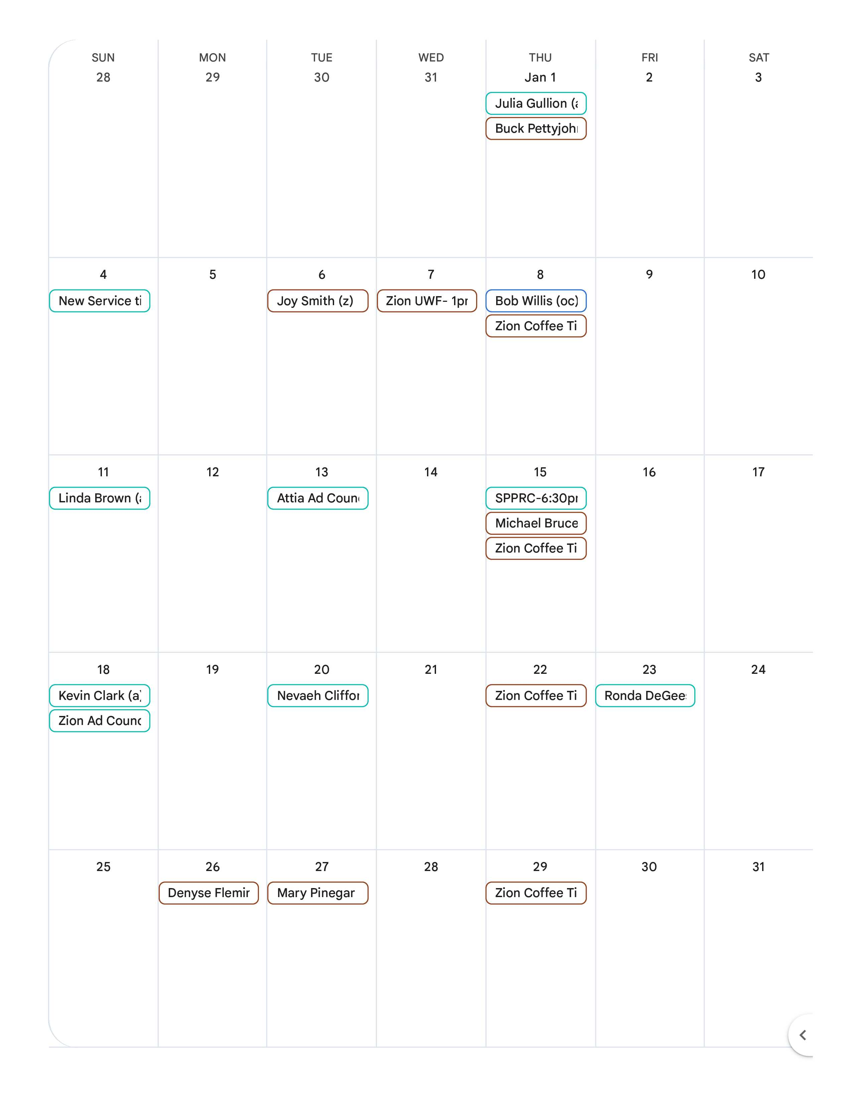
February 2026

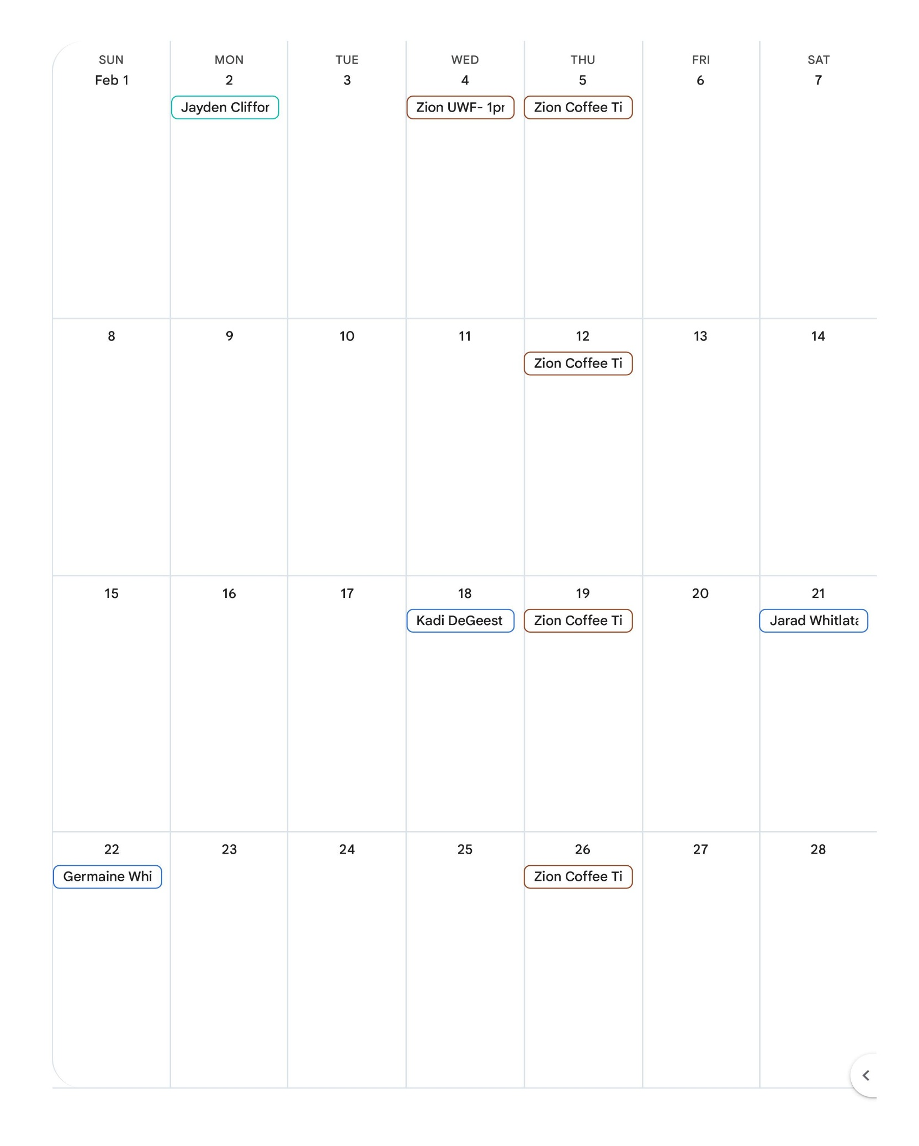
March, 2026
